Triangle Centroid

Definition
# Source: AI Source: Provided by: [Data Path: Persons Table -> ID Column: 1, Name_En Column: Motasem Essam] -> From: [ChatGPT] on [7/25/2026]
The Triangle Centroid is the point where the three medians of a triangle intersect.
The centroid is commonly denoted by:
$$\boxed{G}$$
For triangle $△ABC$, if:
- $D$is the midpoint of $\overset{‾}{BC}$
- $E$is the midpoint of $\overset{‾}{AC}$
- $F$is the midpoint of $\overset{‾}{AB}$
then:
$$\overset{‾}{AD}, \overset{‾}{BE}, \overset{‾}{CF}$$
are the three medians, and they intersect at the centroid $G$.
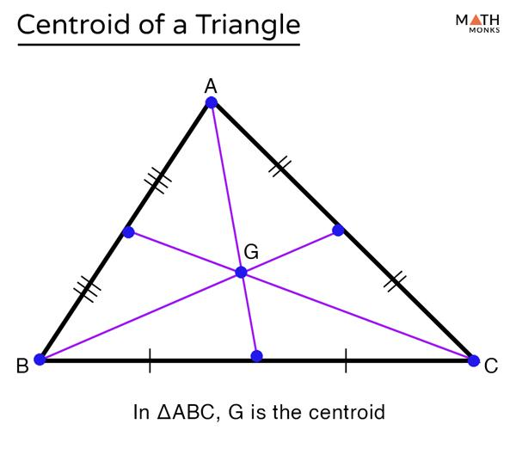
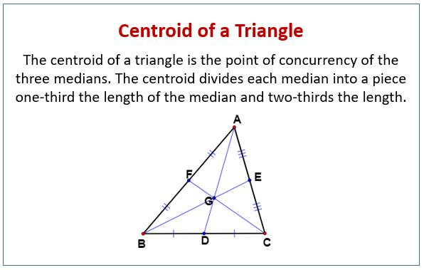
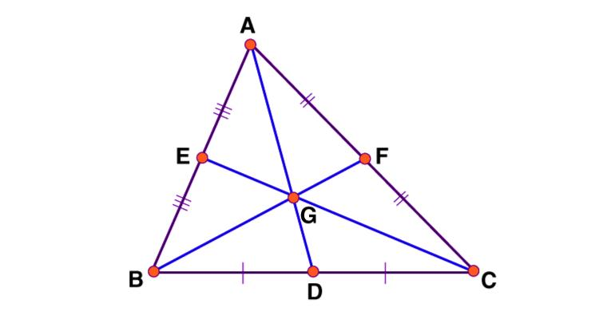
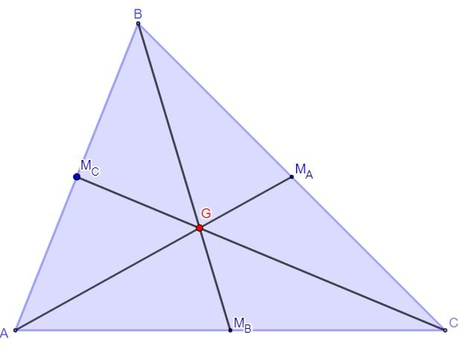
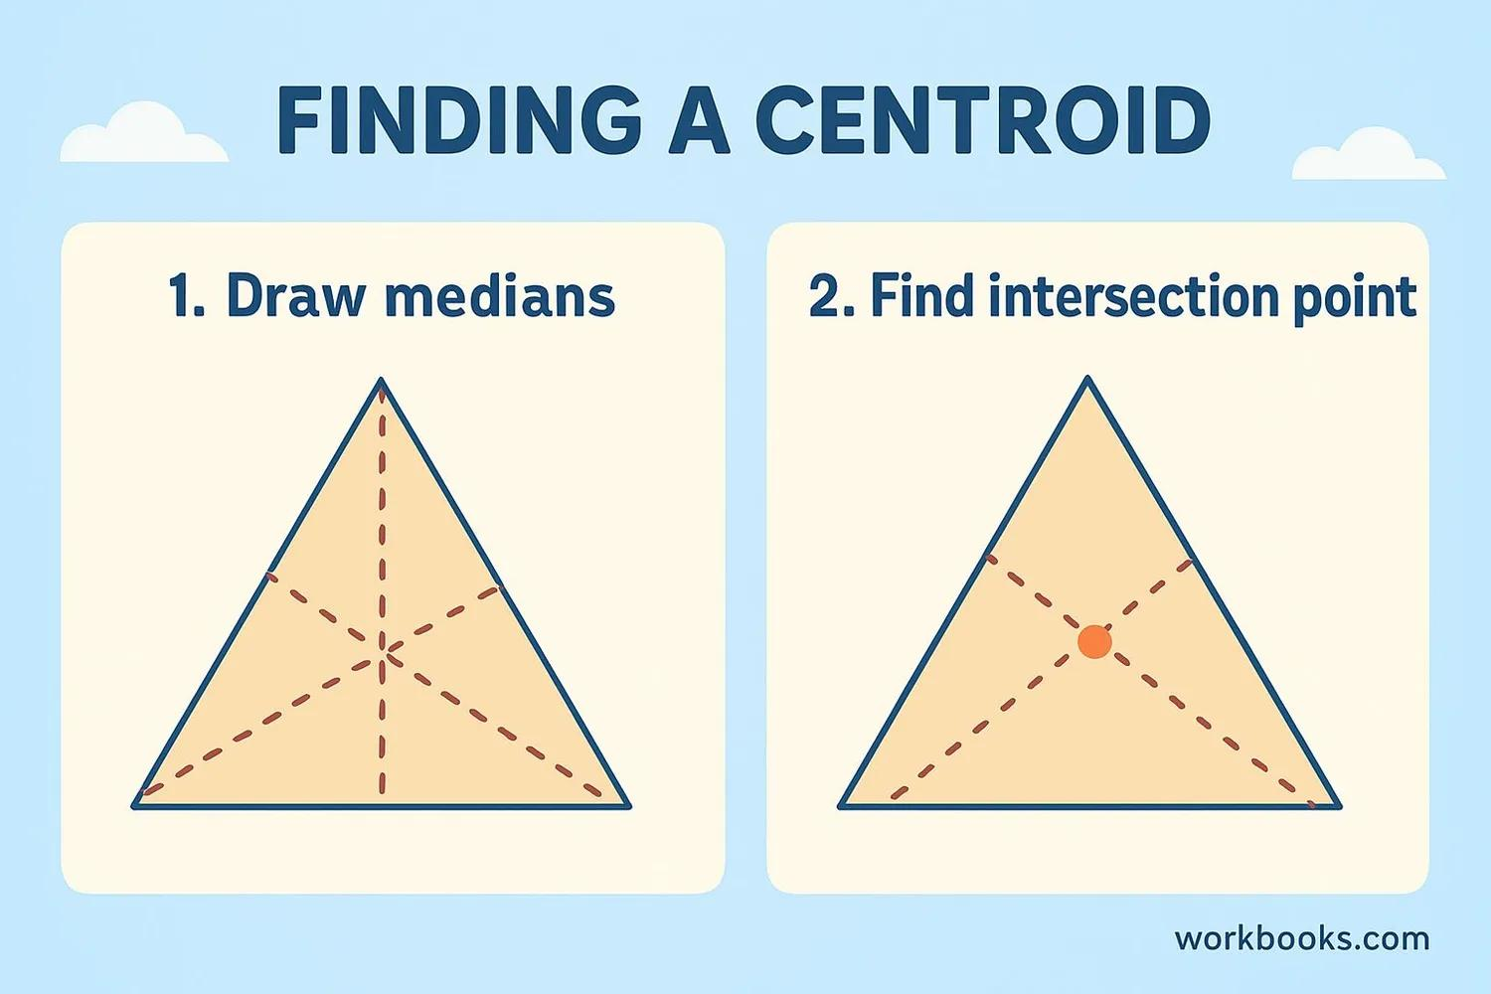

Purpose
# Source: AI Source: Provided by: [Data Path: Persons Table -> ID Column: 1, Name_En Column: Motasem Essam] -> From: [ChatGPT] on [7/25/2026]
The centroid is used to:
- Locate the geometric center of a triangle.
- Study the relationships between medians and side midpoints.
- Divide medians into known ratios.
- Find the balance point of a triangular lamina of uniform density.
- Solve coordinate-geometry problems.
- Analyze centers of triangles and their relationships.

Fundamental Elements
# Source: AI Source: Provided by: [Data Path: Persons Table -> ID Column: 1, Name_En Column: Motasem Essam] -> From: [ChatGPT] on [7/25/2026]
For $△ABC$:
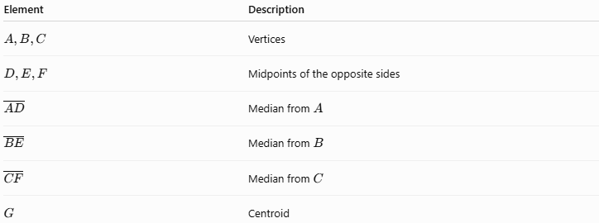
Element | Description
$$A,B,C$$ | Vertices
$$D,E,F$$ | Midpoints of the opposite sides
$$\overset{‾}{AD}$$ | Median from $A$
$$\overset{‾}{BE}$$ | Median from $B$
$$\overset{‾}{CF}$$ | Median from $C$
$$G$$ | Centroid
The defining relationship is:
$$\boxed{G=\overset{‾}{AD}∩\overset{‾}{BE}∩\overset{‾}{CF}}$$

Medians and the Centroid
# Source: AI Source: Provided by: [Data Path: Persons Table -> ID Column: 1, Name_En Column: Motasem Essam] -> From: [ChatGPT] on [7/25/2026]
A median is a segment joining a vertex of a triangle to the midpoint of the opposite side.
Therefore:
$$D\text{ is midpoint of }BC$$
implies:
$$\overset{‾}{AD}\text{ is a median}$$
Similarly:
$$\overset{‾}{BE}, \overset{‾}{CF}$$
are medians.
The three medians are concurrent, meaning they all pass through one common point:
$$\boxed{G}$$
That common point is the centroid.

Centroid Theorem
# Source: AI Source: Provided by: [Data Path: Persons Table -> ID Column: 1, Name_En Column: Motasem Essam] -> From: [ChatGPT] on [7/25/2026]
The Centroid Theorem states:
The three medians of a triangle intersect at a single point called the centroid, and the centroid divides each median in a $2:1$ratio.
Therefore, if $G$lies on median $\overset{‾}{AD}$:
$$\boxed{AG:GD=2:1}$$
Thus:
$$\boxed{AG=\frac{2}{3}AD}$$
and:
$$\boxed{GD=\frac{1}{3}AD}$$
The same relationship applies to all three medians:
$$\boxed{BG:GE=2:1}$$
and:
$$\boxed{CG:GF=2:1}$$
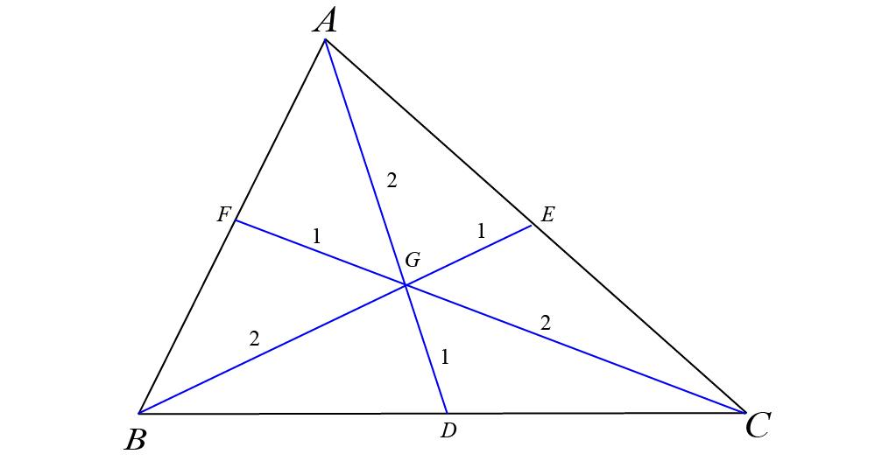
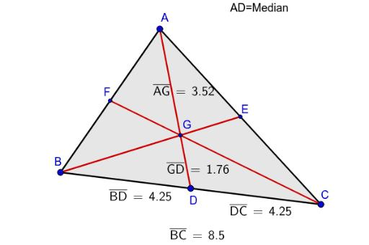
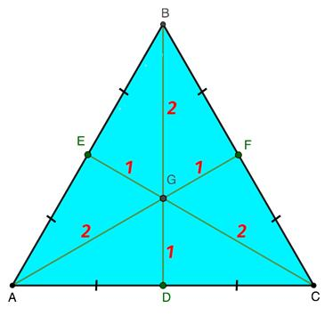
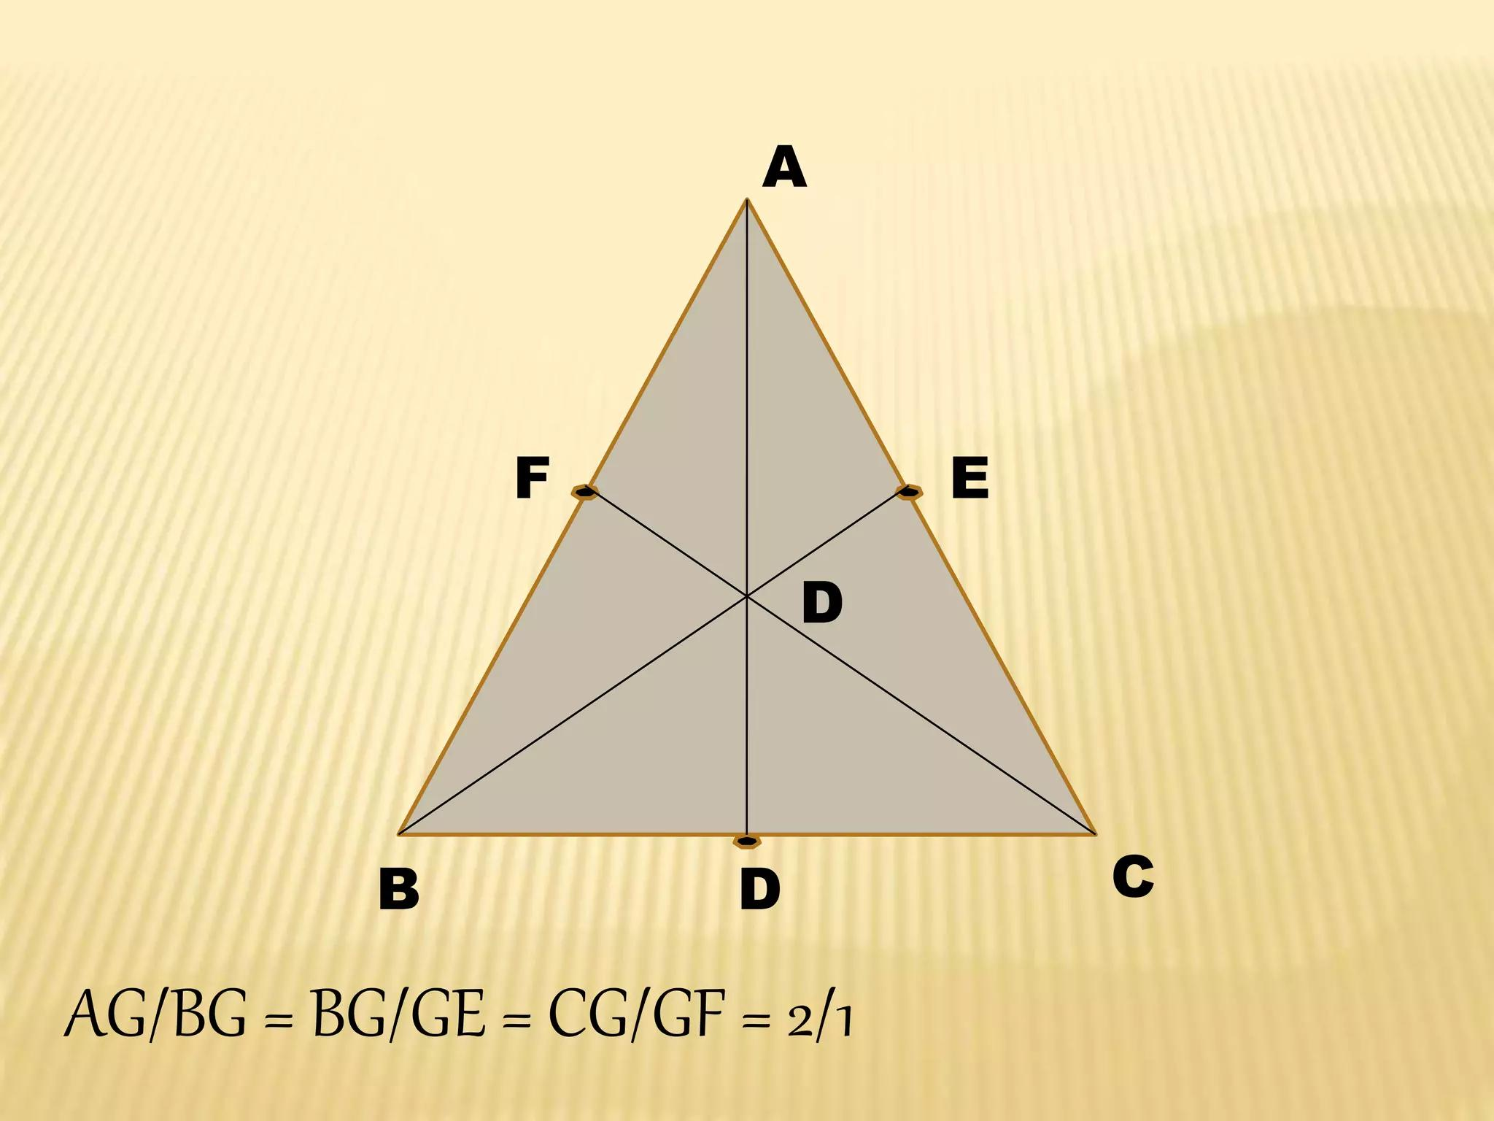
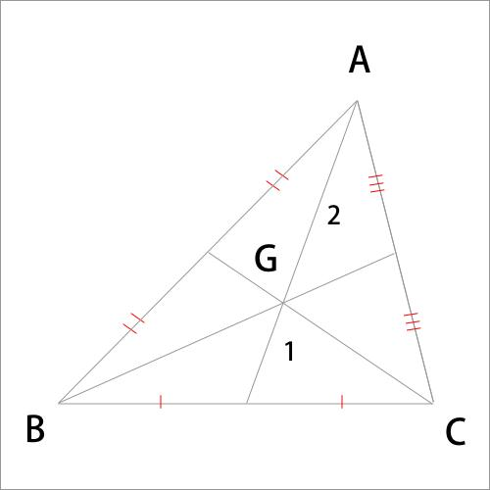

Important Property: $2:1$Ratio
# Source: AI Source: Provided by: [Data Path: Persons Table -> ID Column: 1, Name_En Column: Motasem Essam] -> From: [ChatGPT] on [7/25/2026]
The centroid is always located two-thirds of the way from a vertex toward the midpoint of the opposite side.
For example:
$$AD=12$$
Then:
$$AG=\frac{2}{3}\left(12\right)=8$$
and:
$$GD=\frac{1}{3}\left(12\right)=4$$
Therefore:
$$AG:GD=8:4=2:1$$

Coordinate Formula
# Source: AI Source: Provided by: [Data Path: Persons Table -> ID Column: 1, Name_En Column: Motasem Essam] -> From: [ChatGPT] on [7/25/2026]
If the vertices of a triangle are:
$$A=\left(x_{1} , y_{1}\right) \\ B=\left(x_{2} , y_{2}\right) \\ C=\left(x_{3} , y_{3}\right)$$
then the centroid is:
$$\boxed{G=\left(\frac{x_{1}+x_{2}+x_{3}}{3} , \frac{y_{1}+y_{2}+y_{3}}{3}\right)}$$
In three-dimensional coordinate geometry, if:
$$A=\left(x_{1} , y_{1} , z_{1}\right) \\ B=\left(x_{2} , y_{2} , z_{2}\right) \\ C=\left(x_{3} , y_{3} , z_{3}\right)$$
then:
$$\boxed{G=\left(\frac{x_{1}+x_{2}+x_{3}}{3} , \frac{y_{1}+y_{2}+y_{3}}{3} , \right)}$$
with the $z$-coordinate completed as:
$$\boxed{G=\left(\frac{x_{1}+x_{2}+x_{3}}{3} , \frac{y_{1}+y_{2}+y_{3}}{3} , \frac{z_{1}+z_{2}+z_{3}}{3}\right)}$$

Example: Finding the Centroid
# Source: AI Source: Provided by: [Data Path: Persons Table -> ID Column: 1, Name_En Column: Motasem Essam] -> From: [ChatGPT] on [7/25/2026]
Given:
$$A=\left(2 , 1\right) \\ B=\left(8 , 1\right) \\ C=\left(5 , 7\right)$$
The centroid is:
$$G=\left(\frac{2+8+5}{3} , \frac{1+1+7}{3}\right)$$
Therefore:
$$G=\left(\frac{15}{3} , \frac{9}{3}\right) \\ \boxed{G=\left(5 , 3\right)}$$

Vector Representation
# Source: AI Source: Provided by: [Data Path: Persons Table -> ID Column: 1, Name_En Column: Motasem Essam] -> From: [ChatGPT] on [7/25/2026]
The centroid can also be expressed using position vectors:
$$\boxed{\vec{OG}=\frac{\vec{OA}+\vec{OB}+\vec{OC}}{3}}$$
This means that the centroid is the average of the position vectors of the three vertices.

Centroid and Area
# Source: AI Source: Provided by: [Data Path: Persons Table -> ID Column: 1, Name_En Column: Motasem Essam] -> From: [ChatGPT] on [7/25/2026]
The three medians divide a triangle into six smaller triangles of equal area.
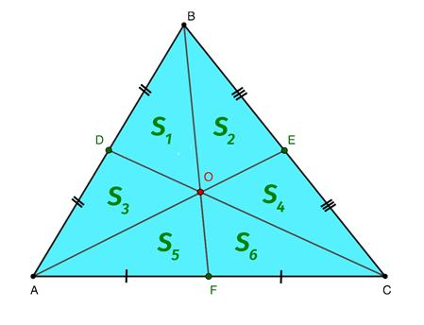
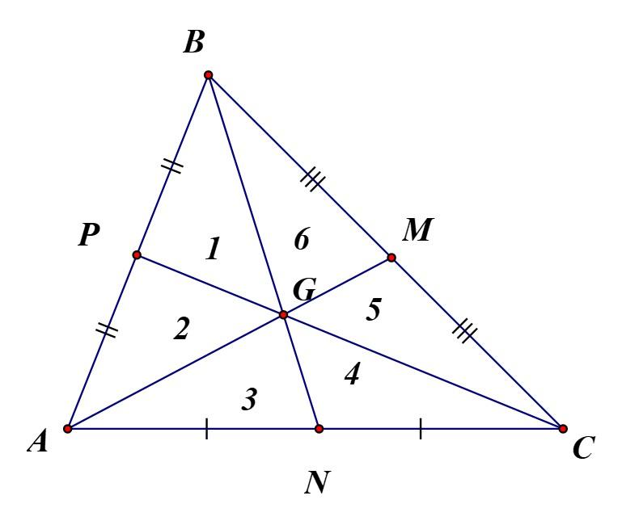
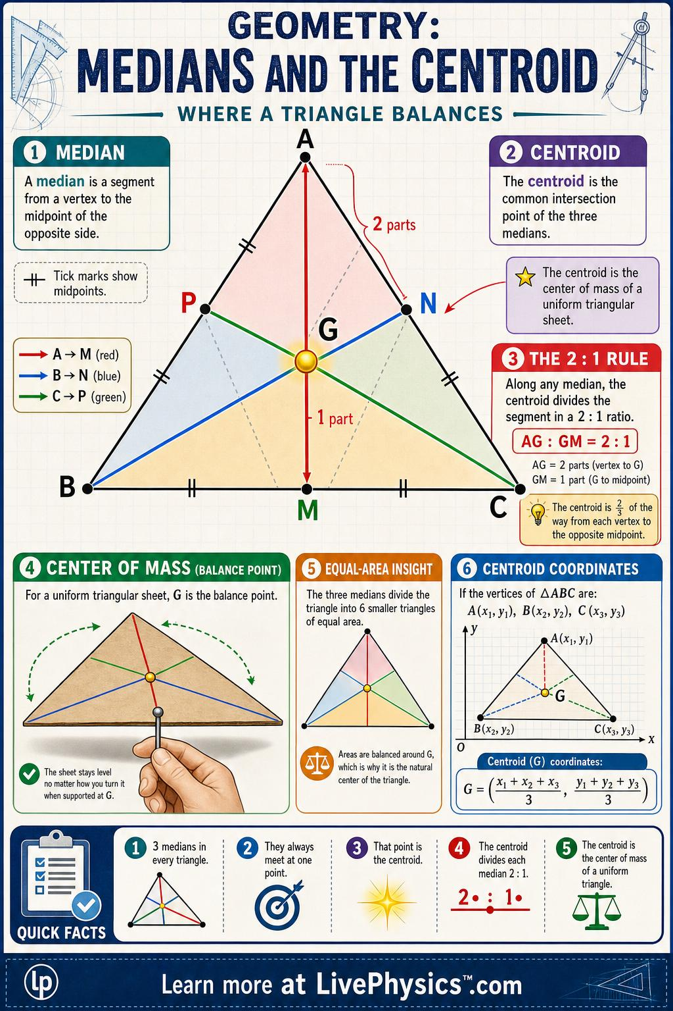
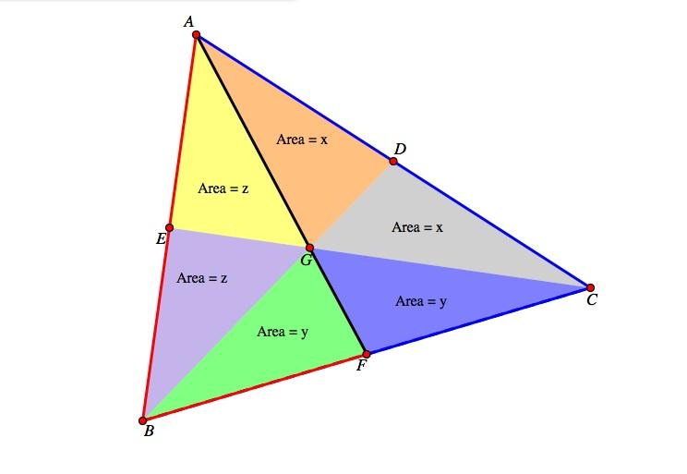
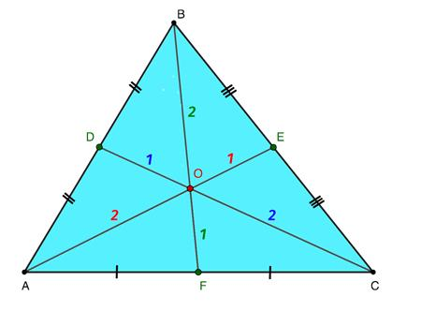
If the area of the original triangle is:
$$A$$
then each of the six smaller triangles has area:
$$\boxed{\frac{A}{6}}$$
This follows because the centroid divides each median in a $2:1$ratio and the resulting triangles have equal areas in the appropriate pairs.

Centroid as a Balance Point
# Source: AI Source: Provided by: [Data Path: Persons Table -> ID Column: 1, Name_En Column: Motasem Essam] -> From: [ChatGPT] on [7/25/2026]
For a triangular plate of uniform density, the centroid is its center of mass.
If the triangle is made from a uniform material, it can theoretically be balanced at its centroid.
This is why the centroid is sometimes described as the balance point of a triangle.

Centroid in Different Triangle Types

Equilateral Triangle
# Source: AI Source: Provided by: [Data Path: Persons Table -> ID Column: 1, Name_En Column: Motasem Essam] -> From: [ChatGPT] on [7/25/2026]
For an equilateral triangle, the centroid coincides with several other triangle centers:
$$\boxed{\text{Centroid}=\text{Circumcenter}=\text{Incenter}=\text{Orthocenter}}$$

Isosceles Triangle
# Source: AI Source: Provided by: [Data Path: Persons Table -> ID Column: 1, Name_En Column: Motasem Essam] -> From: [ChatGPT] on [7/25/2026]
The centroid lies on the triangle's axis of symmetry.

Scalene Triangle
# Source: AI Source: Provided by: [Data Path: Persons Table -> ID Column: 1, Name_En Column: Motasem Essam] -> From: [ChatGPT] on [7/25/2026]
The centroid generally has no symmetry, but it still lies at the intersection of all three medians.

Right Triangle
# Source: AI Source: Provided by: [Data Path: Persons Table -> ID Column: 1, Name_En Column: Motasem Essam] -> From: [ChatGPT] on [7/25/2026]
The centroid lies inside the triangle and can be calculated using the coordinate formula.

Location of the Centroid
# Source: AI Source: Provided by: [Data Path: Persons Table -> ID Column: 1, Name_En Column: Motasem Essam] -> From: [ChatGPT] on [7/25/2026]
The centroid of every nondegenerate triangle lies inside the triangle.
Unlike some other triangle centers, the centroid never lies outside the triangle.
$$\boxed{G∈interior⁡\left(△ABC\right)}$$

Centroid vs Median
# Source: AI Source: Provided by: [Data Path: Persons Table -> ID Column: 1, Name_En Column: Motasem Essam] -> From: [ChatGPT] on [7/25/2026]
These terms should not be confused.
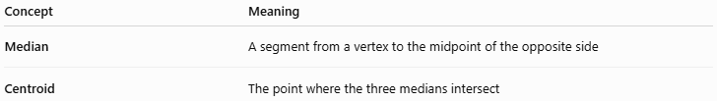
Concept | Meaning
Median | A segment from a vertex to the midpoint of the opposite side
Centroid | The point where the three medians intersect
Therefore:
$$\boxed{\text{Medians are segments; the centroid is a point.}}$$

Centroid vs Other Triangle Centers
# Source: AI Source: Provided by: [Data Path: Persons Table -> ID Column: 1, Name_En Column: Motasem Essam] -> From: [ChatGPT] on [7/25/2026]
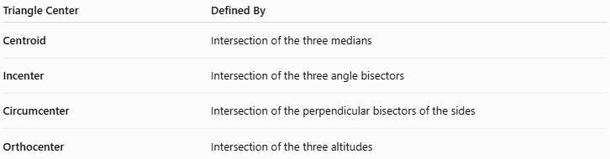
Triangle Center | Defined By
Centroid | Intersection of the three medians
Incenter | Intersection of the three angle bisectors
Circumcenter | Intersection of the perpendicular bisectors of the sides
Orthocenter | Intersection of the three altitudes
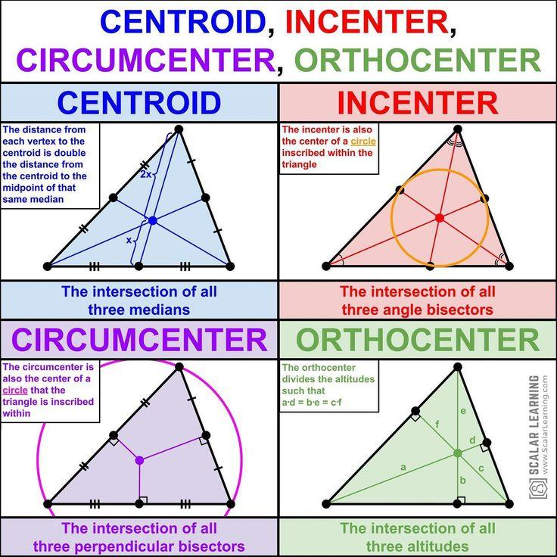
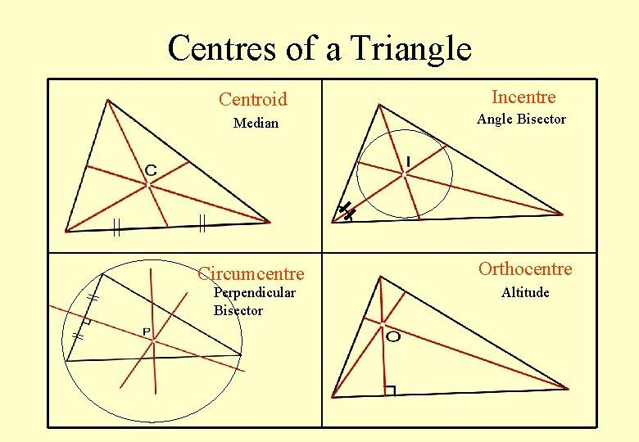
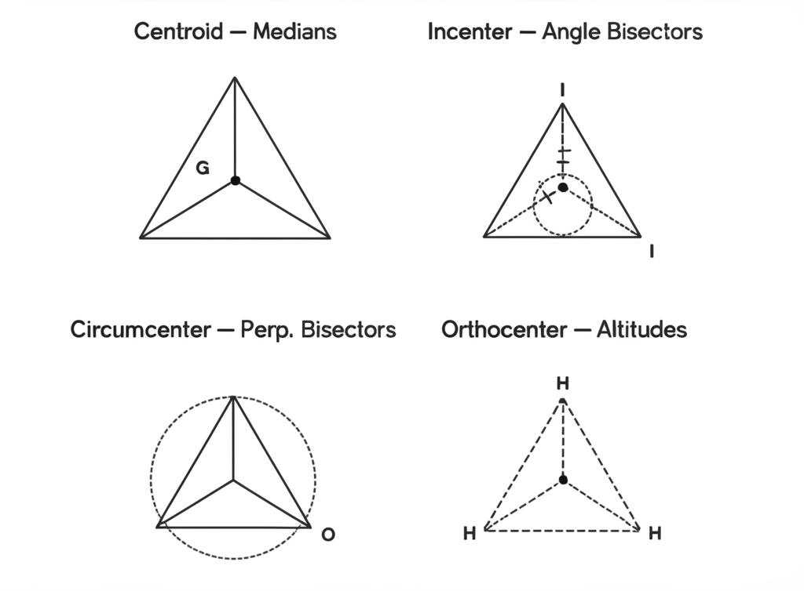
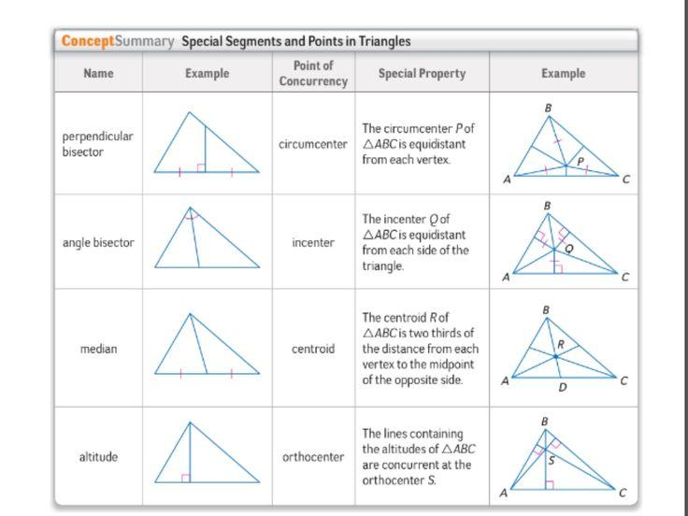
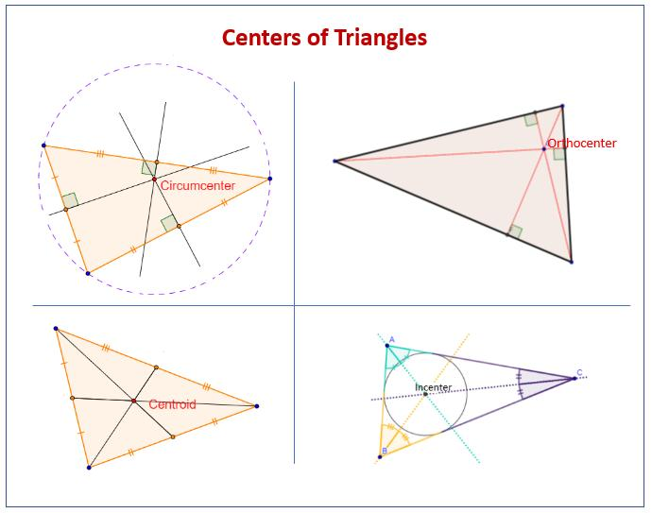

Relationship with the Midsegment
# Source: AI Source: Provided by: [Data Path: Persons Table -> ID Column: 1, Name_En Column: Motasem Essam] -> From: [ChatGPT] on [7/25/2026]
The centroid is closely related to midpoints and therefore to midsegments.
If $D,E,F$are the three side midpoints, then the segments connecting these points form the medial triangle.
The medians pass from the original vertices toward these midpoint locations, and their common intersection is the centroid.
Thus, the centroid is naturally connected to:
$$\boxed{\text{Vertices}→\text{Medians}→\text{Side Midpoints}}$$

Key Properties
# Source: AI Source: Provided by: [Data Path: Persons Table -> ID Column: 1, Name_En Column: Motasem Essam] -> From: [ChatGPT] on [7/25/2026]
- Every nondegenerate triangle has exactly one centroid.
- The centroid is the intersection of the three medians.
- The three medians are always concurrent.
- The centroid divides every median in a $2:1$ratio.
- The longer portion is always adjacent to the vertex.
- The centroid lies inside the triangle.
- The centroid is the average of the vertex coordinates.
- The three medians divide the triangle into six equal-area triangles.
- For a uniform triangular lamina, the centroid is its center of mass.
- In an equilateral triangle, the centroid coincides with the other principal triangle centers.

Conclusion
# Source: AI Source: Provided by: [Data Path: Persons Table -> ID Column: 1, Name_En Column: Motasem Essam] -> From: [ChatGPT] on [7/25/2026]
The Triangle Centroid is the unique point where the three medians of a triangle intersect. It has two fundamental properties:
$$\boxed{G=\text{intersection of the three medians}}$$
and
$$\boxed{AG:GD=BG:GE=CG:GF=2:1}$$
It can also be found directly from the vertices using:
$$\boxed{G=\left(\frac{x_{1}+x_{2}+x_{3}}{3} , \frac{y_{1}+y_{2}+y_{3}}{3}\right)}$$
The centroid is therefore one of the most important triangle centers, connecting medians, midpoints, ratios, coordinates, area, and center of mass.

